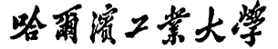


Report of Software Architecture

Homework 6.2-1: Legacy File Update Using Pipes-and-filters Architecture

Basic information
Team name： _______________________________
Class number: ___________________________________________________
Department/school：
Team members with student numbers：

_______________________

Instructor’s comments and score
comments：

score：
signature of the instructor：

Year month date

- Requirements of the project：
Run the program PipeFilterTestGui before you actually do any coding. After you run the program, a graphical user interface will appear as below.
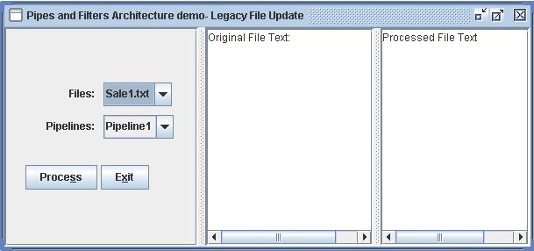

As you can see from the above graphical user interface, there are two options, one is the legacy files to be processed, and the other is the pipeline used for processing the files.
The file name such as “Sale1.txt” is the name of the actual old .txt file to be processed. You can also put other files into the directory “LegacyFiles” for processing.
If you choose a file name from the Files combox, and then choose one pipeline pipeline1, then the program will start inputting lines from Sale1.txt and then invoke AssemblyOfPipeLines, which will in turn run the pipeline 1 as the following

InputFilter➔Y2kFixFilter➔AnnotFilter➔OutputFilter
to fix Y2K problem, add annotations to each line, and finally output the processed contents to a file Updated.txt and at the same time to display the contents to the screen. See the pipeline bellow.
sale .txt

InputFilter
OutputFilter
Y2kFixFilter
AnnotFilter

Updated.txt
Screen

Fig 1. The pipeline 1 of the filters

Specifically speaking, the program will run in the following manner.
- InputFilter reads the file to be processed in character stream format and parses the file. The parsed data is written to the output pipe as char stream.
- Y2kFixFilter reads character stream from its source pipe, fix Y2k problem, e.g, change 96-12-09 into 1996-12-09, and then write processed contents as character stream into its sink pipe
- AnnotFilter read character stream from the source stream (through source pipe), and add some annotations to each line, and then write the resultant data into sink pipe as character stream
- OutputFilter reads character stream from the source stream (through source pipe), and then write the resultant data into a file named Updated.txt in directory “NewFiles” and onto the right textArea on the GUI (the original file content will be shown on the left textArea)

Now, all the files
  - PipeFilterTestGui.java,
  - AssemblyOfPipeLines.java,
  - InputFilter.java,
  - Y2kFixFilter.java,
  - AnnotFilter.java, and
  - OutputFilter.java
have all been implemented.

What you should do. You are required to (需要你完成的部分)
- Write a Java class called PoliticalFilter.java to find every phrase “Republic of China” in the file and change it into “Taiwan”.
- then inside class AssemblyOfPipeLines.java, you need to insert the objects of PoliticalFilter.java into the pipeline to form a new PIPELINE2 as below.

InputFilter
Y2kFixFilter
sale .txt
PoliticalFilter

OutputFilter
AnnotFilter

Updated.txt
Screen

Fig 2. The pipeline 2 of the filters

- The new pipeline 2 should be assembled in file AssemblyOfPipeLines.java as option2. Therefore, in order to run the pipeline2, you only need to choose pipeline 2 on the graphical user interface

Report Part

- Draw the new pipeline, namely pipeline 2, of your new design here

- About the design class diagram (参考第16章，例16.6文档更新系统)
  - Draw the original class diagram of the program
  - What class has been added to the class diagram
  - Draw your new class diagram with the added class

3. Answer questions
- What makes the data flow through the pipeline?
- Why all the filters can work simultaneously ?

4. Typical input and output from running your program

